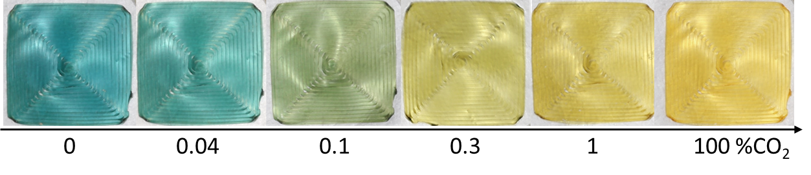



#22140e

#281811





#160d09

#1c110c





#0b0604

#110a07